Annual Report 2022-23
Department of English

In the month of July the classes of B.A/B.Sc/ B.Com Second and Third year and M.A III Semester had been started. There are approximately 190 students studying English Literature at the undergraduate and postgraduate levels. Mr. Dharmendra Kumar, Department alumnus, was awarded UGC-NET in the first attempt. Purusharth Das alumus of department has joined Army Nursing for serving the country. Two research scholar Monika Tolani and Satyaveer Singh Rathore donated books to the department.
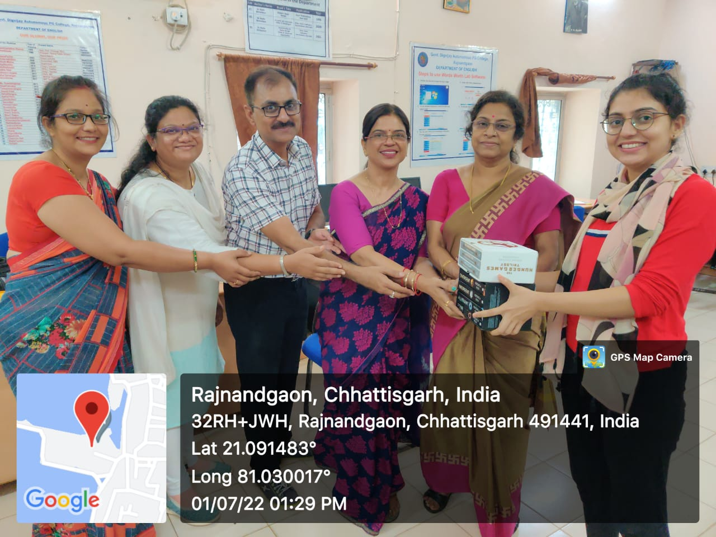

The first activity of the session was the meeting of Board of Studies, which was organised on 23/07/2022 at 12 noon in the English Department to review and redesign the syllabus of PG (MA English Literature), in UG (B.A, B.Sc, B.Com, BCA) CBCS had been introduced in first semester in language and Literature both; in UG (B.A, B.Sc, B.Com ,B.C.A) second and third year and Add-on-Course in spoken English and Creative Writing old pattern would be continued. The following board members were present in the meeting-
Chairman- Dr Anita Shankar
Sub. Expert (VC Nominee)- Dr. Rashmi Dubey
Sub. Expert (Principal Nominee)- Dr. Rabinder Chhabra
Sub. Expert (Principal Nominee)- Dr, Shiny Mendonce
Advisory Member- Darshan Bajaj
Alumni Member – Ms Ranjana Ambade

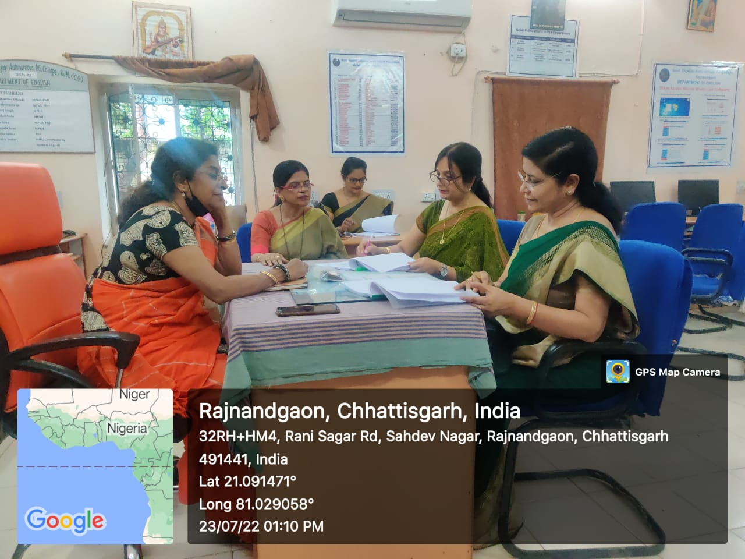

On 19/07/2022, Plantation activity was organised by the department. Teachers and students planted various saplings like Karanj, Palm, Snake Plant,etc.

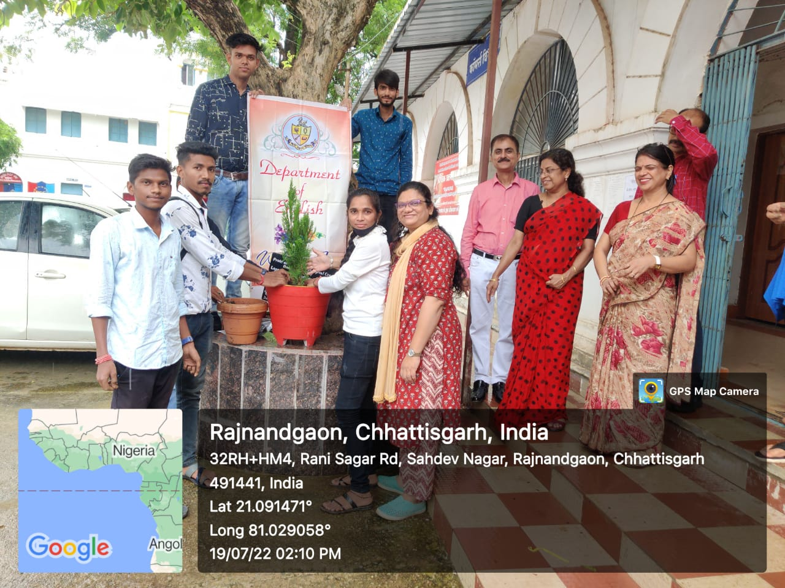

On 23/07/2022, department of English celebrated G.B.Shaw’s birthday. A speech competition on life and works of Shaw was organized.

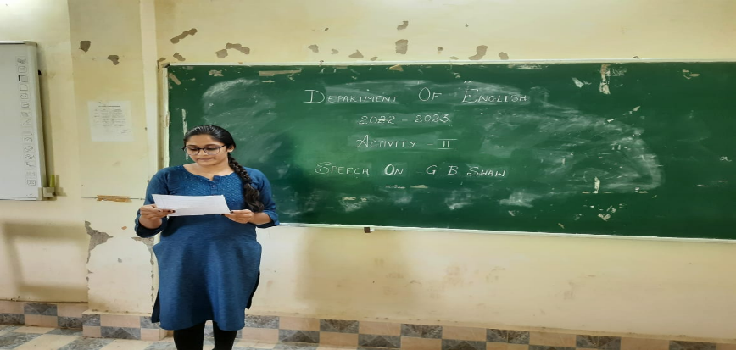

On 8/09/2022, the department of English conducted a quiz competition on Rabindranath Tagore for students of M.A I sem, III sem and B.A I/II/III.

On 24/09/2022, department had celebrated T.S.Eliot’s birthday. Students of PG organized a poetry recitation competition and they also discussed about the life and works of T.S Eliot on the occasion.

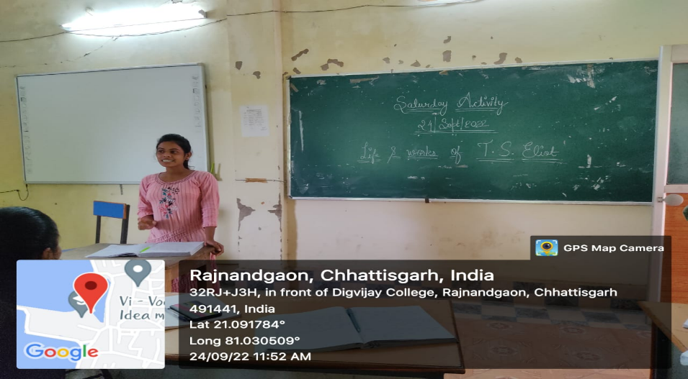

On 1/10/2022, a story telling competition had been organized by the department. An image was given to the students and asked to interpret the image as per their imagination. On the same day the Cleanliness activity was also done by the department on account of M.K. Gandhi’s birthday.

On 08/10/2022, on account of R.K.Narayan’s birthday students of PG classes organized a poetry and a story telling completion on the works of R.K. Narayan.

The Literary Association was formed on 31/10/2022, in the presence of Dr. K.L.Tandekar, Principal. Govt. Digvijay PG Autonomous College, Rajnandgaon (CG). In the formation of the association, the following office bearers were appointed-
1. President – Ms Shakshi Shukla (MA III semester)
2. Vice President- Ms Meemansa Rajoriya (MA I semester)
3. Secretary – Ms Mridula Singh (MA III semester)
4. Joint Secretary- Mr Ayush Nande (MA I semester)
5. Joint Secretary- Ms Sajal Patel (B.A III)

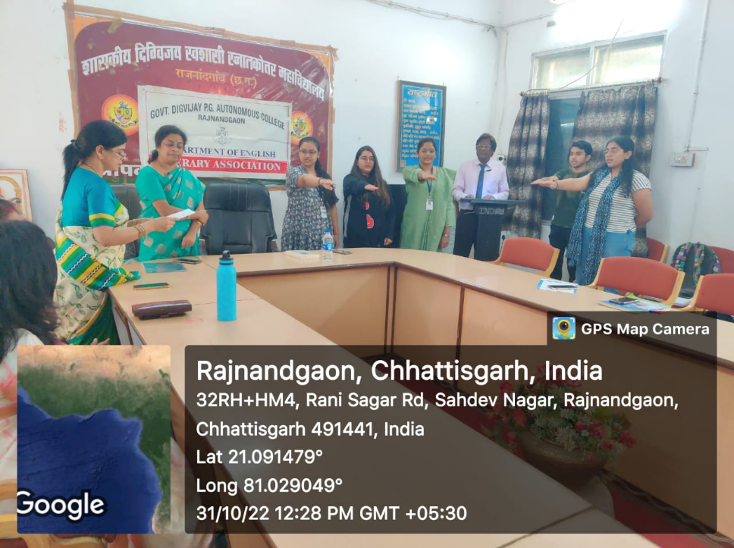

On 16/11/2022, a guest lecture was organized by the department on Waiting for Godot’ by Samuel Beckett. The guest speaker was Dr. Sheila Vijay, Head Dept. of English, Dr.Khubchand Baghel Govt. Pg College, Bhilai-3, Bhilai, Durg (C.G).

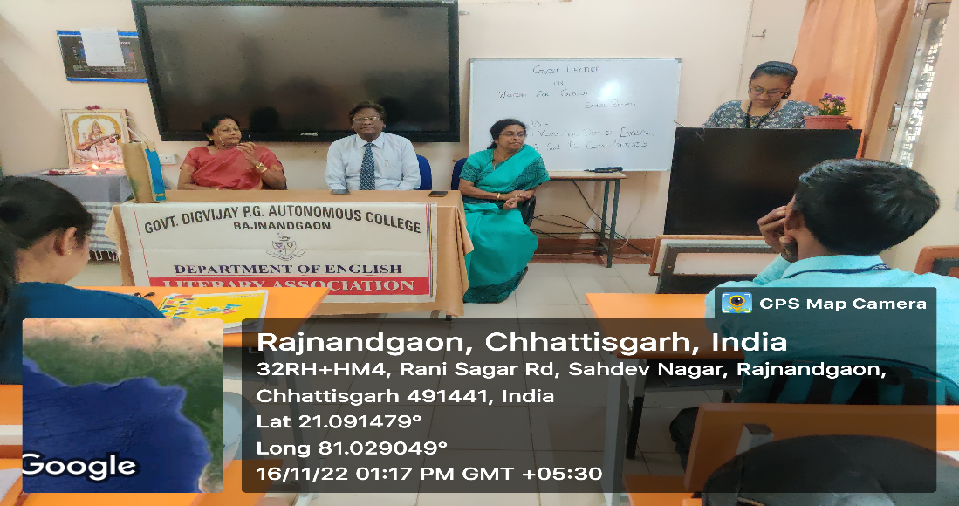

On 18/11/2022, an inter-disciplinary Guest Lecture was organized by the department of English. The guest speaker was Dr. S. Jenamani, Assistant Professor, Department of Geography has delivered a lecture on ‘Geographical Condition of Europe’.
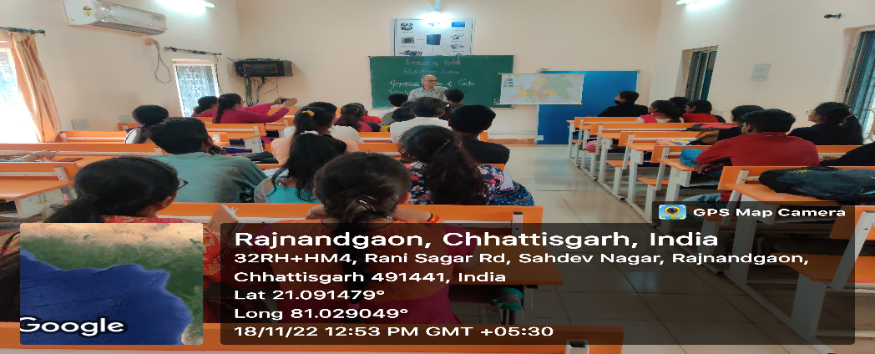

On 19/11/2022, an inter-disciplinary guest lecture was organized by English. The guest speaker was Dr. Shailendra Singh, Head, Department of History has delivered a lecture on ‘History of Europe in the 14th century’.
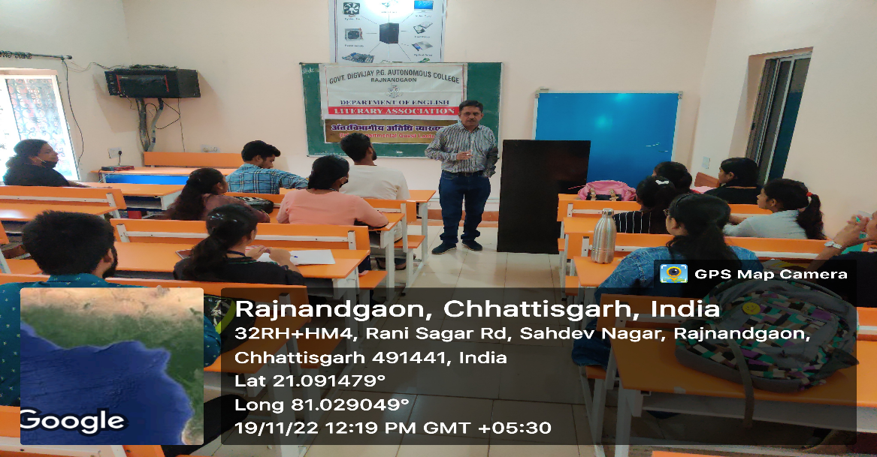

A Five day workshop on ‘Sentence Construction in English’ was organized by the department from 28/11/2022 to 02/12/2022. Mr. Mirza rafi Ahmed, the Director of Mirza’s Academy and a motivational speaker has been invited for the workshop as the spokesperson.
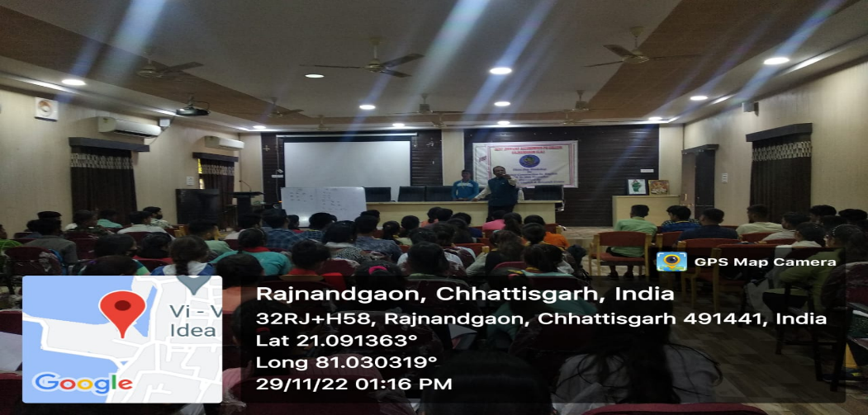

On 09/12/2022, under collaborative activity with Royal College, Rajnandgaon, an extension activity to ‘Abhilasha’, an NGO for the especially abled children has been organised by the department.
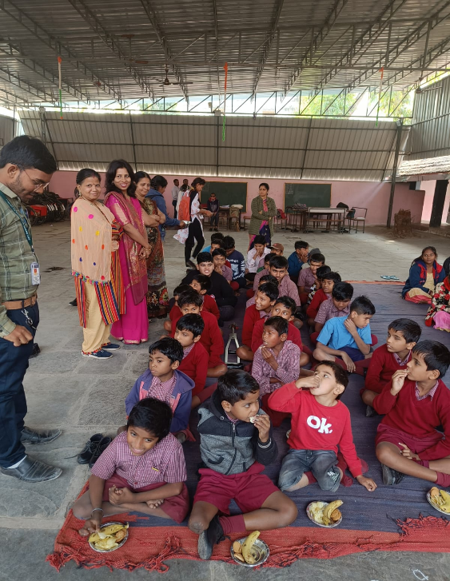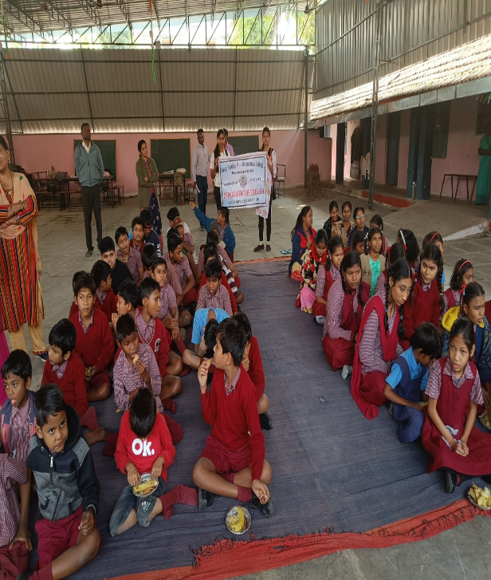
Under MoU, the department of English organized a two day online lecture series from 01/02/2023 to 02/02/2023. The guest speaker for the series was Mr. Mahesh K.M, research scholar, IKSV Khairagarh, delivered lecture on ‘Classification of Consonants and Vowel Sounds’ and ‘Arms and the Man’.
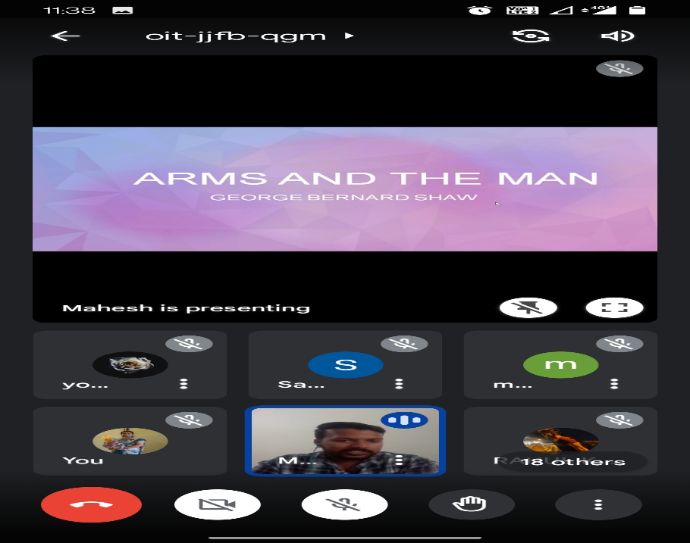

Three Day Workshop on Communicative English
“Literary Association” of the students was formulated on 14th February 2022 and the office bearers were nominated as President, Vice President, Secretary and Joint Secretary. The first activity under Literary Association was a three day Workshop (14th to 16th February 2022) on “Communicative English” for the students of all streams. The resource person was Shri. Rishabh Manikpuri , the founder and Director of Bhasha Academy, Rajnandgaon. The workshop was open for students of all the classes. Students gathered in a good number to get benefitted by the workshop.

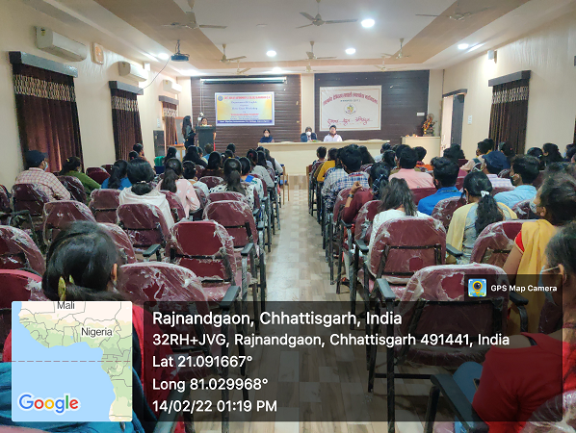

Interdisciplinary lecture on “Hindi Vyakaran ka Mahatva”
On 24th February, 2022, second session, another Interdisciplinary lecture was organised. The invited speaker was Prof. Kaushik Bishi, Assistant Professor, Department of Hindi. The Interdisciplinary lecture was on “ Hindi Vyakaran Ka Mahatv”. He focussed on the “Rasa” theory which is a part of the Critical Theory Paper of M.A. IV Semester.

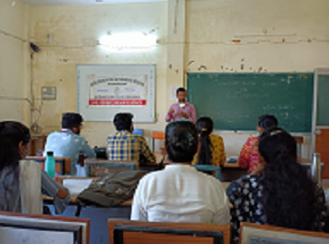

Interdisciplinary lecture on “Artificial Intelligence”

On 24th February, 2022, first session, an Interdisciplinary lecture, the invited speaker was Prof. Mustafa Ansari, Asst. Prof in Computer Science was organised. He dealt with the artificial intelligence, its applications and its future prospects. Prof. Mustafa Ansari explained the future of artificial intelligence and how it will become a part and parcel of our lives. He dealt with not only the benefits but also its hazardous results. He instructed all the students not to give the copies of heir AADHAR or any important document without signing across it and clearly mentioning the name of the person whom you give it and also the purpose.
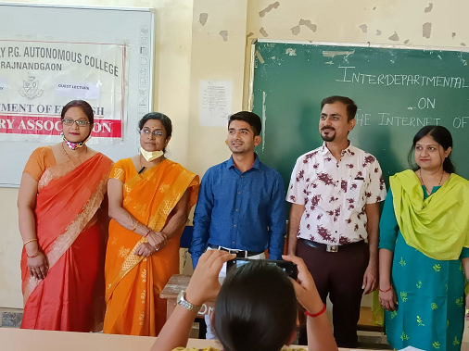

GUEST LECTURE on RESEARCH METHODOLOGY

Today, on 25/02/2022, a guest lecture was organized in the English Department of Digvijay Mahavidyalaya under the guidance of respected Principal Dr. K.L. Tandekar and the able direction of Head of the Department, Dr. Anita Shankar. The main topic of the lecture was ‘What is Research’. In which Dr. Madhu Kamra, Head of Department, English Department, Durga College, Raipur gave his lecture as the keynote speaker. The program started with the address of the Head of the Department and he welcomed the chief guest by giving him a bouquet. Dr. Kamra explained the research methodology and research process in detail in his lecture. The lecture was very useful for students and researchers.
The program was conducted by Aishwarya Srivastava, student, MA final. Vote of thanks was given by Dr. Neelu Srivastava, in-charge of English Research Centre. Professor of the department, Prof. in the program. Chandan Soni, Prof. Manjari Singh, Dr. Anita Saha, Prof. Manjula Soni, Mrs. Radhika Sarkar, Mrs. Rekha Yadav gave their support. A large number of postgraduate students and researchers of the English Department participated in the program and made the program a success.

